The Stock Exchange of Hong Kong Limited takes no responsibility for the contents of this announcement, makes no representation as to its accuracy or completeness and expressly disclaims any liability whatsoever for any loss howsoever arising from or in reliance upon the whole or any part of this announcement.

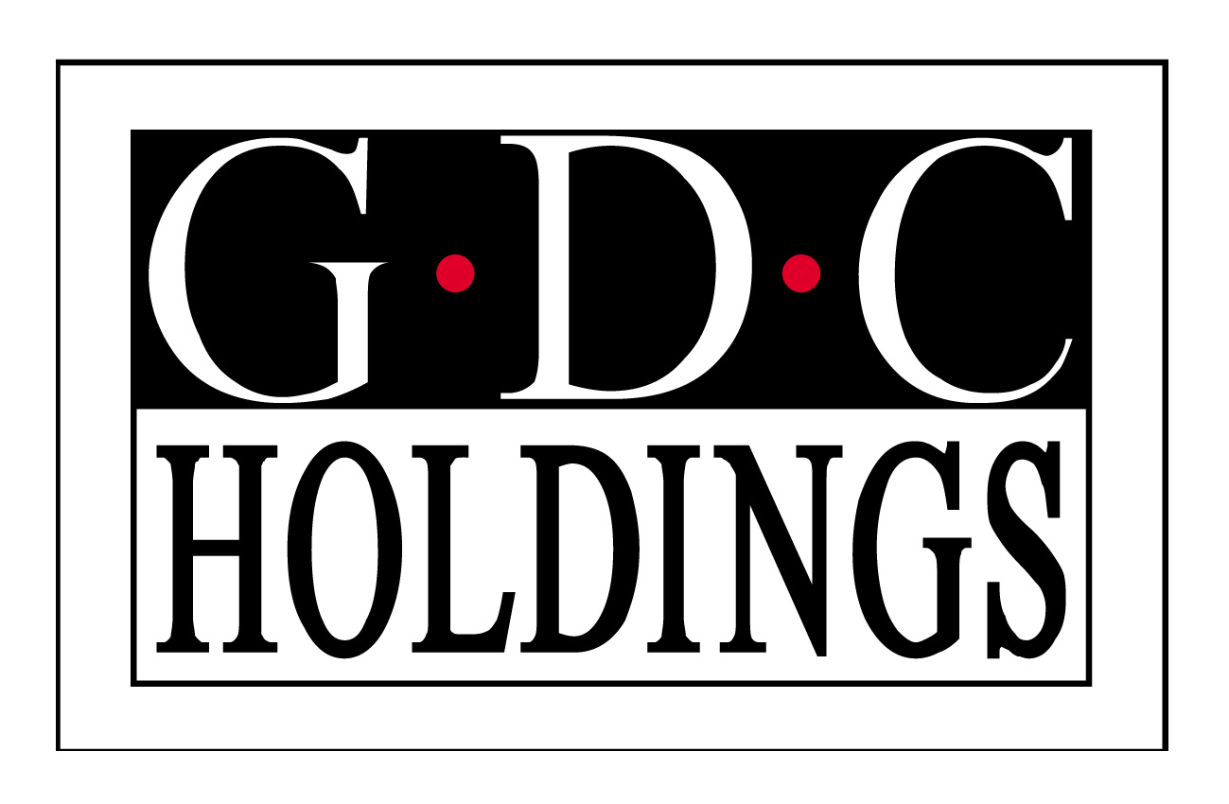

GLOBAL DIGITAL CREATIONS HOLDINGS LIMITED
環球數碼創意控股有限公司*
(Incorporated in Bermuda with limited liability)
(Stock Code: 8271)

ANNOUNCEMENT

The directors (the “Directors”) of Global Digital Creations Holdings Limited (the “Company”) have noted today’s increase in price of the shares of the Company and wish to state that the Directors are not aware of any reasons for such increase.

The Directors also confirm that there are no negotiations or agreements relating to intended acquisitions or realisations which are discloseable under Chapters 19 to 20 of the Rules Governing the Listing of Securities on the Growth Enterprise Market of The Stock Exchange of Hong Kong Limited (“GEM Listing Rules”).

Save for possible negotiation with a third party for development and supply agreement, neither is the board of Directors (the “Board”) aware of any matter discloseable under the general obligation imposed by Rule 17.10 of the GEM Listing Rules, which is or may be of a price-sensitive nature.

Made by the order of the Board of the Company, the directors of which collectively and individually accept responsibility for the accuracy of this announcement.

By Order of the Board
Chen Zheng
Chief Executive Officer

Hong Kong, 16th February, 2007

As at the date of this announcement, the Executive Directors of the Company are Mr. Cao Zhong, Mr. Chen Zheng, Mr. Jin Guo Ping and Dr. Xu Qing, Catherine, the Non-executive Directors is Mr. Leung Shun Sang, Tony, the Independent non-executive Directors are Mr. Kwong Che Keung, Gordon, Mr. Bu Fan Xiao and Mr. Hui Hung, Stephen..

This announcement, for which the Directors of Global Digital Creations Holdings Limited (“the Company”) collectively and individually accept full responsibility, includes particulars given in compliance with the Rules Governing the Listing of Securities on the Growth Enterprise Market ( the “GEM”) of The Stock Exchange of Hong Kong Limited for the purpose of giving information with regard to the Company. The Directors, having made all reasonable enquiries, confirm that, to the best of their knowledge and belief, the information contained in this announcement is accurate and complete in all material respects and is not misleading; there are no other matters the omission of which would make any statement in this announcement misleading; and all opinions expressed in this announcement have been arrived at after due and careful consideration and are founded on bases and assumptions that are fair and reasonable.

This announcement will remain on the GEM website at www.hkgem.com on the “Latest Company Announcements” page for at least 7 days from the day of its posting and at the Company’s website www.gdc-world.com.

